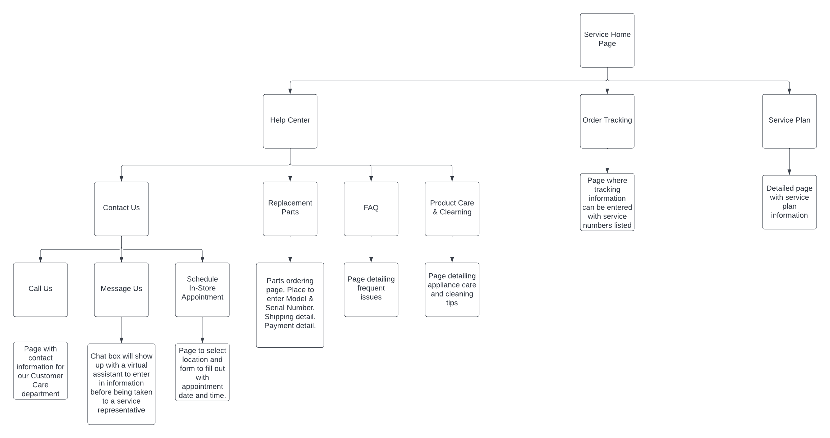 Hierarchal Drawing

Screen Samples

Mobile Platform

I believe our company should develop for mobile as most users own a phone but may not own a computer. Responsive web design is a must so it can be viewed on any device regardless of screen size.

Prototyping

Advantages:

* Test the usability of the product to find problems
* Easy to communicate with users, leaders, and other relevant people
* Improve the efficiency of product design

Disadvantages:

* Time-consuming with great expense
* May constrain the designer’s ideas, the more you design, the smaller space available to the designer.
* It may not be possible to estimate the difficulty of implementation which may cause long development time.